Use Case Management – 7/15/2005

This communication is intended to clarify and reinforce how use cases are managed in collaborative environment through requirements management tool - ReqPro:
- What attribute information is collected for use cases
- Who owns the population of the information
- When action to update information is taken
- How it is all accessible to everyone on the team through ReqPro

Overview:
At the end of the message is a link to a view (query) in the ReqPro tool that contain data extract of Use Cases planned for Iteration 1 – but before accessing the view, please review detailed information about attribute information for use cases and the process for updating them.

The picture below is the layout legend of what you will see:
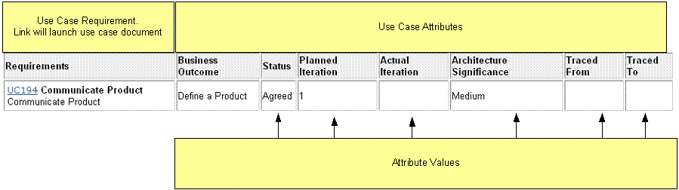

Here is explanation on what it means and what the process is for managing each of the attributes:

Attribute | Value | Purpose | Role/Process
Business Outcome | Define a Product  Place an Order  Collect and Load  Product Dimension  Venue Dimension  Process and Deliver – DMC  Process and Deliver – MAT  Check and Support – JETS  Check and Support – DIV  Check and Support – MOD  Check and Support - MMS | This attribute reflect use case origination broken by Business Outcome categories | Attribute value is set by Business Analyst (BA)
Status | Identified  Authored  Agreed  Analyzed  Designed  Incorporated  Validated  Obsolete | This attribute determine use case lifecycle status. It’s intended to assess the progress of evolution of intended functionality. The goal is to have use case go from Identified to Verified state within the span of one iteration. However, based on refined estimates and execution – Use Case can be Agreed to in Iteration 1 but would not get Designed or Implemented or Verified until later iteration. | - Identified status is set by BA during use case discovery phase  - Authored status is set by BA to indicate the Use Case content is ready for review  - Agreed status is set by BA once use case has gone through the review and all critical priority gaps have been resolved  - Analyzed status is set by BA once technology team is done with use case realization and submitted use case for signoff and analysis artifacts for review. All gaps in functionality resulting from final revisions are incorporated into the Use Case document. Use Case content is locked and placed under change control  During this process some use cases or functionality within the use cases may be re-planned into the future iterations – at that point Actual Iteration value will need to be reset to designate when the functionality will be implemented and verified.  - Designed status is set by Technical Architect (TA) to indicate that implementation of the functionality is in progress  - Incorporated status is set by TA once all implemented functionality for a use case has been deployed into test environment  - Validated status is set by Quality Assurance after performing test execution and resolving all critical priority and severity defects.  - Obsolete status is set by BA as a result of a change control or use case merge through authoring phase
Planned Iteration | Number | Reflect the work that is planned to be completed within iteration. It includes all new use cases that were Identified, Authored, and Agreed upon from the business stand point to go into analysis and design phase in that iteration. | Attribute value is set by Business Analyst based on the outcome of the use case review or sign-off meeting activities.
Actual Iteration | Number | Reflect when use case became Verified. It tracks the work that is happening within the iteration. It includes all use cases that were planned for iteration. In addition, it includes all carry over work not done in the previous iteration from the point it was Agreed upon to the point it was Verified. | Attribute value is set initially by Business Analyst to reflect the outcome of the Analysis outcome. If a use case is planned to be designed and implemented in the same iteration, then actual iteration value will be the same as planned.  Then, if design or implementation does not get done within the span of iteration, then TA must reset actual iteration value to iteration when the work will be done. Finally, actual iteration value can be updated by QA if testing of a use case has been completed satisfactorily at a different iteration.
Architecture Significance | High  Medium  Low | Technical assessment of use case impact on the overall architecture after it has reached Agreed status.  Impact value may determine the order the Use Case gets worked on and implemented. | The attribute value is set by the TA after use case has reached Agreed status.
Traced From | Feature ID | This attribute shows Feature to Use Case relationship | Traceability is set by the Business Analyst at the point when the Use Case is Identified.
Traced To | Use Case Story Board ID | This attribute shows Use Case to Use Case Storyboard relationship | Traceability is set by the System Analyst at the point when the Use Case is realized (applicable to use case that describe front end functionality)

User Specific Views:
In the process of the Use Case management all attributes must be updated accurately and timely according to the process specified above. As a result, all project members can access the view in the tool and determine the state of use case requirements at any point in time. Keep in mind, views can be customized to retrieve only the information that is relevant to you based on attribute value. For example, if you are interested in looking at the progress of use case on Collect and Load only – you can set a filter to only show Use Case that are assigned to Collect and Load Business outcome, for information on how to create private views or customize views please refer to the ReqPro/ReqWebTraining Manual located under the Requirements_Repository\Training folder in the tool.

Accessing Req Pro:
Here is information on how you can access the View. The link to the view that I am providing will let you retrieve all use cases planned for Iteration 1.
Keep in mind planned iteration values reflect everything that was Agreed upon from the business stand point to go into analysis and design phase in that iteration only while the values in Actual Iteration will reflect the work that will actually occur in the iteration. For example if development does not have enough resources, they may push Use Case planned for iteration 1 to be analyzed and designed in iteration 2. Therefore Planned Iteration value will be 1 and Actual Iteration value will be 2.

To access the view in the web client, please access this URL: http://saguaro.infores.com:1080/ReqWeb/ReqsView_Frame.jsp?ViewKey=858&ViewPosRow=1&ViewPosCol=1
Note: This view can also be accessed from the client. It is located at: Requirements_Repository\Analysis Views\MK Infoscan\Use Cases
If you need help accessing the view or need to know what id and password to use while reviewing requirements please review ReqWeb quick start guide.
https://iriteams.infores.com/sites/regfactory/Req%20Team/Training%20Materials/InfoscanMK%20-%20ReqWeb%20QuickStart.doc

